Choice-Head Distillation for Dental Multiple-Choice Question Answering

Tianyuan Chen, Richard Tai-Chiu Hsung*, Harris Sik-Ho Tsang, Wai-Lun Lo, Tony Yu-Lin Zhu, Xiaoxing Yang
Dept. Computer Science
Hong Kong Chu Hai College
Hong Kong SAR, China
0009-0004-0137-8360, {richardhsung, harristsang, wllo, ylzhu, xxyang }@chuhai.edu.hk
Billy Chiu
School of Data Science
Lingnan University
Hong Kong SAR, China
billychiu@ln.edu.hk
Walter Lam
Faculty of Dentistry
The University of Hong Kong
Hong Kong SAR, China
retlaw@hku.hk

Abstract—Medical large language models (LLMs) have achieved excellent results in benchmark evaluations, but they remain costly to deploy in real-world settings. This challenge is especially pronounced in dental multiple-choice question answering tasks on datasets such as the Chinese Medical Exam dataset (CMExam). Although the output space is restricted to five answer options, many distillation approaches for deployment optimization still train using the full vocabulary distribution. In this paper, we introduce the Choice-Head distillation method, a task-aligned method that transfers only the teacher distribution over the answer options rather than over the entire vocabulary. By distilling in the decision space, our approach is computationally lighter than vocabulary-level distillation and remains compatible with black-box API teachers. In our experiments, DeepSeek-V3 is adopted as the teacher and Qwen2.5-7B and Qwen2.5-14B as students on a CMExam-based resplit. We evaluate the distilled models on a 991-question full test set with repeated runs. In some cases, the student outperforms the teacher(s). The best 14B model reaches 89.10% accuracy, exceeding the 87.18% teacher, while the three-seed mean remains 88.67%—suggesting the gains are consistent. These results further indicate that the second hard-label fine-tuning stage may be beneficial. Overall, for structured medical multiple-choice tasks, decision-space (choice-level) distillation is computationally lighter, easier to deploy, and remains compatible with black-box API teachers.
Keywords—knowledge distillation; medical question answering; large language models; multiple-choice reasoning; decision-space supervision

Introduction
Knowledge distillation compresses large models by transferring soft targets to smaller students [1], [2], [8]. Recent medical and general-purpose language models also motivate this direction because strong benchmark results often come with high inference cost and limited deployability [4], [5], [9], [10]. In exam-style medical question answering (QA), this trade-off is especially important because the deployment target is often a smaller assistant model rather than the largest teacher model.
Building on the idea of task-specific knowledge distillation, DistilBERT [2] was introduced to perform distillation in the pre-training phase with large-scale unlabeled text. A compressed model using DistilBERT can be further trained for many downstream tasks. Meanwhile, parameter-efficient fine-tuning also provides a practical training mechanism for distillation. LoRA (Low-Rank Adaptation) adapts large models using low-rank incremental parameters, keeping training costs within a manageable range [3]. Combining LoRA with distillation means that the student can receive the teacher’s soft-label structural information without incurring the hardware burden of full-parameter updates, an important prerequisite for the rapid iteration of the experimental framework used in this paper.
Stronger teachers and larger evaluation sets have improved reported performance [5], [6], [9]-[13]. In the medical and dental domains, automated clinical chatbots represent one of the most rapidly growing areas of interest within digital medicine and dentistry [14]. To rigorously evaluate their capabilities, a primary assessment strategy involves benchmarking the underlying large language models directly against professional board examination questions. In fixed-choice exams, vocabulary-level targets are often poorly aligned with the downstream decision. Although the underlying models are generative, the downstream task behaves like classification. For a five-option exam, the vast majority of the vocabulary is irrelevant to the final choice. As a result, task-aligned (choice-level) targets simplify training while preserving the uncertainty patterns that determine the correct option. This operational advantage becomes especially important when the teacher is accessed via an external API. In such settings, full-vocabulary distillation is frequently unavailable or too costly because the system cannot provide internal logits at scale. By contrast, option-level targets are easier to collect, easier to verify, and straightforward to align with the evaluation benchmark. Overall, our design reduces not only training complexity, but also data-collection and engineering friction.
In this paper, we study the distillation of dental multiple-choice question answering, which is a simple five-option decision task. Current distillation pipelines use full-vocabulary logits [1], [2] or free-form targets [7]. This output design is highly inefficient for a fixed-choice task with only five options, especially when the original model produces a much larger output space. In addition, cloud-based teachers (API teachers) invoke inference services but do not provide internal logits. Since Choice-Head operates only on the five candidate options, low-rank LoRA updates are more likely to capture directions relevant to the answer boundary rather than distributing gradients across the full vocabulary. Regarding evaluation reliability, existing studies [6], [7] often use small medical QA test sets, which are not fully representative. As a result, model rankings can be unstable: a small number of questions can disproportionately influence the final accuracy. To address this, we adopt a CMExam-based re-splitting strategy, using a 991-question set as the main evaluation set. This makes the test results more robust and more informative for model comparison.
The main contributions of this work are as follows:
- We propose Choice-Head distillation, which transfers only the teacher distribution over the five answer options. The method is task-aligned for five-option medical MCQs;
- We show that a student can outperform its teacher: a Qwen2.5-14B student distilled from DeepSeek-V3 reaches 89.10% accuracy on a 991-question CMExam test set, above the teacher accuracy of 87.18%.

Method

Problem Setting
While traditional distillation minimizes divergence across the full token vocabulary, our proposed Choice-Head Distillation focuses exclusively on the distribution over the relevant option set. Given a multiple-choice question $x$ with five candidate options, the goal is to predict the correct option $y ∈ \{A, B, C, D, E\}$. Let $p_{T}$ denote the teacher distribution over these five choices and let $p_{S}$ denote the student distribution over the same set. These two targeted distributions are then used to compute the Stage 1 Kullback-Leibler divergence loss (KL loss) below.

Choice-Head Distillation
The proposed Choice-Head distillation reframes the distillation target around the actual decision space of the task. In the five-option multiple-choice setup, the final answer depends on the relative support assigned to A/B/C/D/E rather than on the full token vocabulary. We therefore compare both teacher and student in the same five-dimensional space. Specifically, we isolate the student’s logits for the five option tokens at the answer position. Let $z_{S,c}$ be the student logit for option $c∈\{A,B,C,D,E\}$. The student option distribution $p_{S}$ is obtained by applying a softmax over the five candidate options:
$$p_{S}\left(c\right)=\frac{\exp\left(z_{S,c}\right)}{\sum_{c^{'}∈\left\{A,B,C,D,E\right\}}{\exp\left(z_{S,c'}\right)}}$$
The teacher distribution $p_{T}$ can be obtained from different sources and is used as the teacher term in the Stage 1 KL loss. For a white-box teacher, the output logits can be read directly. For an API teacher, they can recover approximately with a smoothed soft label based on the returned answer. In either case, the training signal is restricted to the five answer choices, which makes the method compatible with black-box teachers and cheaper than full-vocabulary distillation. It also matches this paper’s setup: DeepSeek-V3 is accessed via an API rather than deployed locally, so full-vocabulary logits are unavailable and strict white-box, vocabulary-level distillation cannot be directly performed.

Stage 1: Choice-Head KL Distillation
Stage 1 injects the teacher's option-level preference structure into the student. It combines the teacher’s soft-label distribution with the ground-truth answer provided by the dataset. The loss is defined as:
$$L_{stage1} = α D_{KL}(p_{T} ∥ p_{S}) + (1 - α)L_{CE}.$$
Here, the KL term $D_{KL}$ compares $p_{T}$ with $p_{S}$ and encourages the student to match the teacher's relative preference over the five options. The term $L_{CE}$ denotes the cross-entropy loss computed against the gold answer, so it keeps the prediction aligned with the dataset label. The coefficient $α$ controls the balance between teacher-distribution supervision and gold-answer supervision; in the main setting, $α$ is set to 0.35. This stage is intentionally short: for the main 14B student, Stage 1 is trained for one epoch. The aim is structure injection, not full teacher imitation, since overfitting teacher labels can amplify its errors. The fine tuning is achieved with low-rank LoRA.

Stage 2: Gold-Answer SFT Calibration
Stage 2 starts from the resulted weights learned in Stage 1 and continues supervised fine-tuning using only the gold answers. Its purpose is to correct possible bias introduced by teacher errors and to pull the student back toward the official answer $y^{*}$ for input $x$ when the teacher signal is misleading. Here $θ$ denotes the trainable parameters of the student model. The loss is:
$$L_{stage2} = -log P_{θ}(y^{*} | x).$$
Intuitively, Stage 1 gives the student a relative map of the five candidate options, while Stage 2 uses the gold answer $y^{*}$ to mark the final destination on that map. This can be useful when the student is weak and needs stronger answer-level correction.

Experimental Setup
The evaluation uses a CMExam-based resplit with 6,590 single-choice medical questions across seven subjects [6]. The training, validation, and test splits contain 4,608, 991, and 991 questions. A 125-question dental subset is extracted for specific performance analysis. The resplit follows a 70/15/15 partition and is stratified by difficulty, which makes the large test set more representative than the small specialty-only setting used in earlier experiments. A 991-question test does not eliminate uncertainty, but it reduces the chance that a strong result is caused by a favorable sample rather than by a stable improvement in decision quality. The teacher is DeepSeek-V3 [5]. The students are Qwen2.5-7B-Instruct (7B student) and Qwen2.5-14B-Instruct [4] (14B student). Training uses LoRA with rank 16 and LoRA alpha 32 [3]. For the main 14B setting, Stage 1 is run for one epoch with learning rate 1 × 10⁻⁴.
Teacher labels cover the full training split. In the full-data setting, the teacher and ground truth disagree on about 12.2% of the training questions. This shows that the teacher provides nontrivial relative preferences instead of merely repeating the gold label, while remaining stable enough to serve as a useful transfer source. The CE term carries a weight of 0.65 in Stage 1, on disagreement samples the gold answer still imposes the main constraint on the final prediction direction, while the KL term preserves the teacher's relative preferences among the five candidate options. The 991-question set is used in the main benchmark for overall effectiveness while the dental subset is for domain-specific checks. For key comparisons, we run repeated experiments on the same data split and prompt format to better measure stability and the upper bound of performance. All results use exact-match accuracy on the final option choice. The prompt format is fixed across teacher and student runs, so observed differences reflect model quality rather than prompting changes which helping isolate the contribution of decision-space supervision from prompting effects.
Finally, the evaluation uses a strictly closed answer space during both label generation and testing. Each question is mapped to one of five predefined options, not free-form text, ensuring the metric reflects correctness of the final choice (and avoids noise from plausible but non-committal explanations). This alignment makes the comparison more directly relevant to the paper’s central claim about decision-space transfer.
TABLE I. Results on the CMExam full set and subset. Full = 991-question full test set; Dental Test = 125-question dental subset.
Model | Setting | Full Test Accuracy | Dental Test Accuracy
Qwen2.5-7B | Zero-shot baseline | 76.49% | 68.80%
Qwen2.5-14B | Zero-shot baseline | 83.55% | 74.40%
DeepSeek-V3 | Teacher | 87.18% | 79.20%
Qwen2.5-7B | Stage 1 mean | 85.60% | 73.60%
Qwen2.5-14B | Stage 1 mean | 88.67% | 79.20%
Qwen2.5-14B | Stage 1 best | 89.10% | 78.40%

Results and Discussion
Choice-Head distillation improves both the full 991-question test set rather than the 125-question dental subset. On the full test set, the 7B student rises from 76.49% to 85.60%, a gain of 9.11 percentage points. The 14B student rises from 83.55% to 88.67% on average, a gain of 5.12 percentage points. The best 14B run reaches 89.10%, exceeding the 87.18% teacher. Fig. 2 visualizes these gains. The results are stable across three seeds. The 14B distilled model achieves accuracy in the range 88.40%–89.10%, with a spread of 0.70%. The mean and the best results therefore support the same conclusion: the task-aligned student is consistently competitive with, and in the best case stronger than teacher.
The Role of Stage 2 SFT Calibration: Additional Stage 2 runs show that supplementary gold-answer fine-tuning does not consistently improve performance after Stage 1. For both 7B and 14B students, the best or average results do not depend on an additional Stage 2 update, suggesting that hard-label calibration can weaken useful soft-label structure after the option-level signal has already been transferred. Therefore, Stage 2 may be treated as an optional distillation step; its usefulness depends on student capacity, teacher reliability, and data scale.
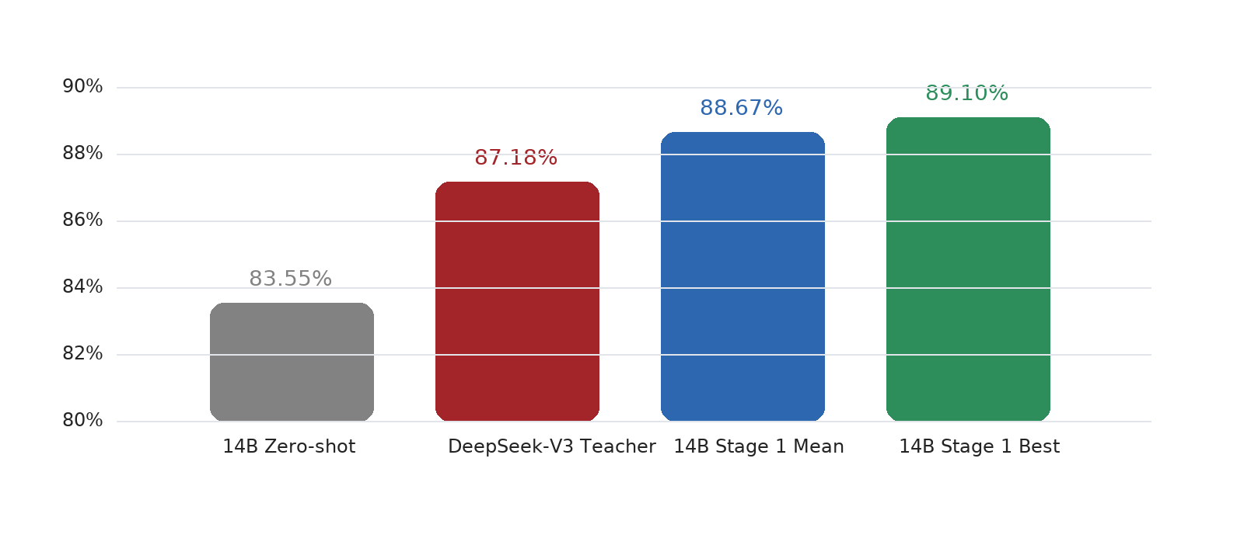Fig. 1. Main results on the 991-question full test set. The distilled 14B student improves over the zero-shot baseline and exceeds the teacher; the best run reaches 89.10%, while the three-seed mean remains 88.67%.
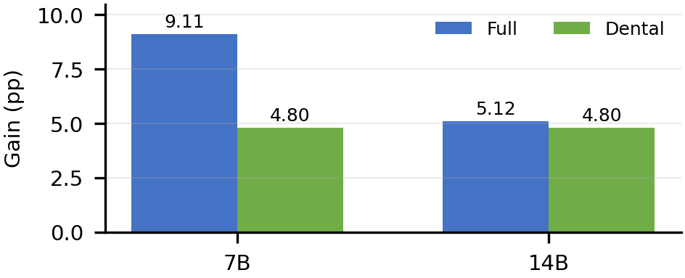
Fig. 2. Accuracy gains over zero-shot baselines on full and dental tests.
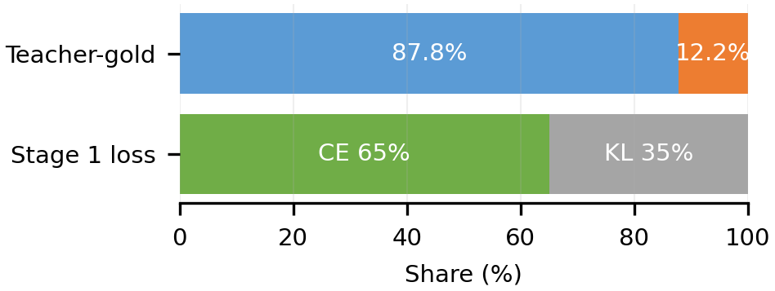
Fig. 3. Teacher-gold agreement and Stage 1 loss weights. CE dominates disagreement cases while KL preserves option preferences.
Student-Over-Teacher Dynamics: The phenomenon of the student outperforming the teacher does not imply that the teacher model lacks general capability. Instead, a more plausible explanation is that the student is optimized within a narrower, more precisely aligned decision space. While the teacher provides rich, relative preferences across the five options (A/B/C/D/E), the training dataset enforces the factual constraints of the gold-standard answers. Synthesizing these dual signals within a restricted five-option output space yields a smoother, more task-specific decision boundary than training on hard labels alone. Therefore, the student surpassing the teacher is not a matter of simply copying the teacher; it simultaneously exploits the teachers option-structure information and the gold answer's correction of teacher errors. It should be noted that the relatively high weight of the CE term does not mean the method degenerates into ordinary supervised fine-tuning: on samples where the teacher agrees with the gold answer, the KL term still provides relative preferences among the options (dark knowledge), complementing the CE term. Fig. 3 summarizes this teacher-gold and CE/KL balance.
Scope of Applicability: Overall, these results support the central observation of this work. For structured, five-option medical examinations, knowledge distillation should directly target the exact decision space dictated by the evaluation metric. This targeted approach concentrates the supervision signal, reduces vocabulary dimensions irrelevant to the final decision, and yields compact student models that are significantly more viable for real-world deployment. Importantly, these conclusions should not be broadly generalized to open-ended clinical dialogue or rationale generation. Tasks requiring complex, generative language behaviors inevitably demand broader vocabulary supervision and distinct alignment objectives.

Practical Implications and Limitations
The key practical impact is that current decision-space distillation alters deployment trade-offs. Instead of replicating all teacher outputs, the goal becomes distilling to a small student, so the model reproduces the final predicted outputs. In standardized multiple-choice medical questions, this outcome fidelity is the decision that matters in practice. This logic applies to distillation for education systems and low-cost assessment tools, where inference cost, model size, and usability are often as critical as benchmark accuracy.
The results also clarify when the method should be preferred over more general distillation objectives. If the downstream task is evaluated by a small and explicit answer set, then transferring a full-vocabulary distribution may add cost without adding useful supervision. In that setting, option-level transfer provides a cleaner training signal and a simpler debugging path. When the student fails, the failure can be inspected directly at the answer-choice level instead of being buried in a large token distribution that is only indirectly related to the final decision. At the same time, the method has clear limits. The present experiments focus on fixed-choice dental and medical exam questions. They do not show that the same target is sufficient for open-ended diagnosis, rationale generation, or interactive clinical dialogue. Those tasks depend on broader language behavior and would require a different supervision target. The current evidence therefore supports a task-specific claim: for structured five-option exams, decision-space supervision is more effective; however, it does not mean it can replace general language-model distillation.
Another limitation is that the current study evaluates a single strong teacher and a narrow family of student architectures. That is enough to establish the central result, but not enough to show that every teacher-student pair will behave the same way. Future work should test whether the same pattern holds across more teacher qualities, more student sizes, and more medical subdomains. Another possible direction is to combine decision-space supervision with selective data filtering, so that ambiguous or low-value training cases are handled differently from clear high-signal examples. In addition, this work does not include a direct full-vocabulary distillation control, so it cannot strictly prove that option-level distillation necessarily outperforms vocabulary-level distillation in terms of performance. This limitation arises from the experimental setup for API-based model distillation (e.g., DeepSeek-V3). Because the model is accessed only through an API and its weights are not available, we cannot access internal logits or the full vocabulary distribution. As a result, strict white-box, full-vocabulary distillation is not possible under the same conditions.

Conclusion
This paper proposes Choice-Head distillation for dental multiple-choice question answering. The method distills only the five-option answer distribution rather than the full vocabulary, aligning the supervision with the task and maintaining compatibility with black-box teachers. On the 991-question CMExam-based test set, in several cases the student surpasses the teacher: the best 14B student achieves 89.10% accuracy, exceeding the 87.18% DeepSeek-V3 teacher. The corresponding three-seed mean of 88.67% indicates that the improvement is consistent rather than confined to a single run. Overall, for structured medical multiple-choice tasks, choice-space distillation offers a practical route to smaller and more deployable QA systems.

Acknowledgment
The work described in this paper was supported by Hong Kong Chu Hai College.

References
- G. Hinton, O. Vinyals, and J. Dean, "Distilling the knowledge in a neural network," in Proc. NIPS Deep Learn. Representation Learn. Workshop, Montreal, Canada, 2015, arXiv:1503.02531.
- V. Sanh, L. Debut, J. Chaumond, and T. Wolf, "DistilBERT, a distilled version of BERT: smaller, faster, cheaper and lighter," arXiv preprint arXiv:1910.01108, 2019.
- E. J. Hu, Y. Shen, P. Wallis, J. Allen-Zhu, Y. Li, S. Wang, L. Wang, and W. Chen, "LoRA: Low-rank adaptation of large language models," arXiv preprint arXiv:2106.09685, 2021.
- Qwen Team, "Qwen2.5 technical report," arXiv preprint arXiv:2412.15115, 2024.
- DeepSeek-AI, "DeepSeek-V3 technical report," arXiv preprint arXiv:2412.19437, 2024.
- T. Liu, M. Yang, Z. Lu, Q. Chen, S. Zhou, and S. Xiang, "Benchmarking Large Language Models on CMExam: A Comprehensive Chinese Medical Exam Dataset," in Adv. Neural Inf. Process. Syst., 2023.
- H. Zhang, J. Chen, F. Jiang, F. Yu, N. Chen, J. Li, G. Chen, and S. Cui, "HuatuoGPT, towards taming language models to be a doctor," in Findings Assoc. Comput. Linguistics: EMNLP 2023, 2023.
- J. Gou, B. Yu, S. J. Maybank, and D. Tao, "Knowledge distillation: A survey," Int. J. Comput. Vis., vol. 129, no. 6, pp. 1789-1819, 2021.
- K. Singhal, S. Azizi, T. Tu, S. S. Mahdavi, J. Wei, H. W. Chung, N. Scales, A. Tanwani, H. Cole-Lewis, S. Pfohl, P. Payne, M. Seneviratne, L. Gaeabler, J. Liu, Z. Dai, C. Mclean, D. S. Webster, P. Balaguer, A. S. Chen, G. S. Corrado, Y. Matias, S. Natarajan, Y. Liu, V. Rajpurkar, A. Karton, and A. Shetty, "Large language models encode clinical knowledge," Nature, vol. 620, pp. 172-180, 2023.
- A. J. Thirunavukarasu, D. S. J. Ting, K. Elangovan, L. Gutierrez, T. F. Tan, and D. S. W. Ting, "Large language models in medicine," Nat. Med., vol. 29, pp. 1930-1940, 2023.
- R. C. W. Chau et al., "Performance of Generative Artificial Intelligence in Dental Licensing Examinations," Int. Dent. J., vol. 74, no. 3, pp. 616-621, Jun. 2024.
- R. C. W. Chau, K. M. Thu, O. Y. Yu, E. C. M. Lo, T.-C. Hsung, and W. Y. H. Lam, "Response to Generative AI in Dental Licensing Examinations: Comment," Int. Dent. J., vol. 74, no. 4, pp. 897-898, Aug. 2024.
- R. C. W. Chau, K. M. Thu, O. Y. Yu, E. C. M. Lo, T.-C. Hsung, and W. Y. H. Lam, "Evaluation of Chatbot Responses to Text-Based Multiple-Choice Questions in Prosthodontic and Restorative Dentistry," Dent. J., vol. 13, no. 7, p. 279, Jul. 2025.
- W. Y. H. Lam, R. C. W. Chau, K. M. Thu, O. Y. Yu, E. C. M. Lo, and T.-C. Hsung, "Digital Dentistry in Clinical Practice: A Scoping Review of Current Capabilities and Future Directions," Int. Dent. J., vol. 76, no. 1, Feb. 2026, Art. no. 109296.

